

**Early Years Spring Term 2**

**Home Learning**

Please discuss these activities with your child and support them where necessary. If you are unsure about any of the activities or need resources, please ask.

**Due back**: The children’s home learning is due back anytime before the 1st April.

**Fairy Tales**

**Create your own potion!**

With an adult, think about what your potion is for. Alice had a potion to make her smaller. What is your potion going to do? Draw your potion and write what it does.

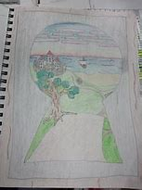

|  |
| --- |
|  |

**The Gingerbread Man**

Think about the Gingerbread Man. Design and then create your own Gingerbread Man. You can make him ouy of gingerbread, cardboard, paper or any materials you have at home. What colour are his buttons going to be?

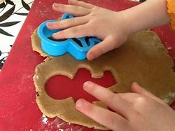

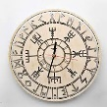

**Story Talking Time**

Does your child have a favourite story that they know really well?

See if they can tell you all about their favourite book or story. You can give them some clues to help if needed, like:

Who is in the story?

Where does it happen?

What happens?

How does it all end up?

Or you could tell the story, but make some mistakes can they spot where you go wrong...?!

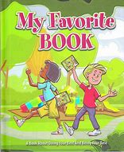

**Working with Others**

Create the puppets for the story of Little Red Riding Hood and act the story out. Record yourself and upload it to Seesaw.

|  |
| --- |
| Image result for little res riding hood puppets by kids |

**Fairy Tale Character**

What is your favourite fairy tale? Create your favourite fairy tale setting in a box. You can choose your favourite fairy tale to create. Once you have created your fairy tale box can you write the story?

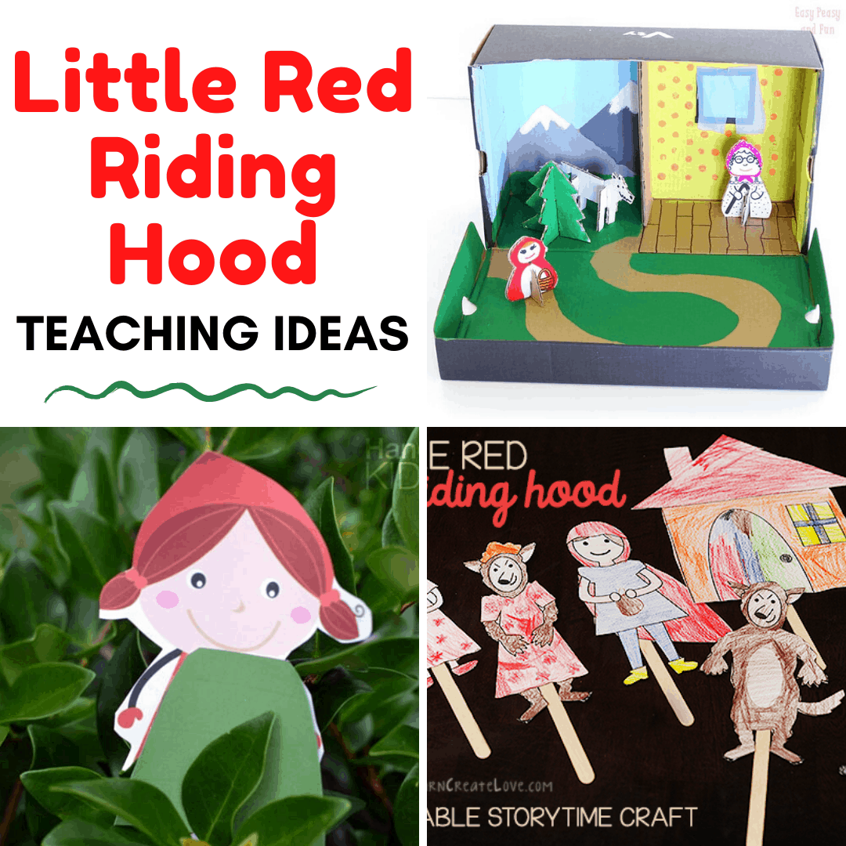

**Shopping**

If you’re going shopping with your child, play a guessing game. Talk about things you’re buying. Can your child guess what it is? E.g. for banana you could say: “It’s yellow and we eat it.”

Back at home, encourage your child to help with unpacking the bags and talk about what you’re unpacking and where it belongs. Give some silly instructions as well as sensible ones. E.g. put the banana in the oven...can your child say why this is a bit silly?!

