

**Year 1 and Year 2 Spring Term 2**

**Home Learning**

Please discuss these activities with your child and support them where necessary. If you are unsure about any of the activities or need resources, please ask.

**Due back**: The children’s home learning is due back anytime before the 1st April.

**Fairy Tales**

**Designing your own Castle!**

Look at different castles and design your own. Remember to think carefully about each part do you want a drawbridge, a turret or a moat?

Once you have designed your own castle gather the materials you need. These can be recycling or any materials you can find at home. Create your castle and remember to paint or decorate it.

Be as creative as you like!

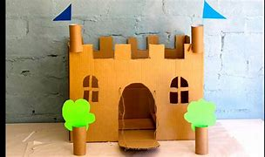 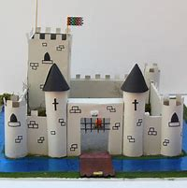

|  |
| --- |
|  |

**Kings and Queens**

Research the past Monarchs of England and select a Monarch you would like to learn more about for example, Queen Elizabeth II. Create a fact file about the Monarch you have chosen.

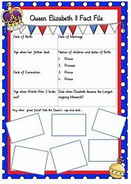 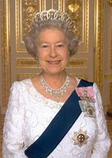

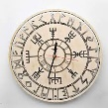

**Plants**

Go for a walk near you home or go in your garden. While you are walking identify as many plants and trees as you can. Draw a picture of these plants and label their parts.

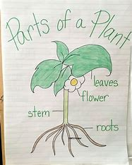

**Working with Others**

Create puppets for the story of Little Red Riding Hood and act the story out. Record yourself and upload it to Seesaw.

|  |
| --- |
| Image result for little res riding hood puppets by kids |

**Fairy Tale Character**

What is your favourite fairy tale? Create your favourite fairy tale setting in a box. You can choose your favourite fairy tale to create. Once you have created your fairy tale box can you write the story?

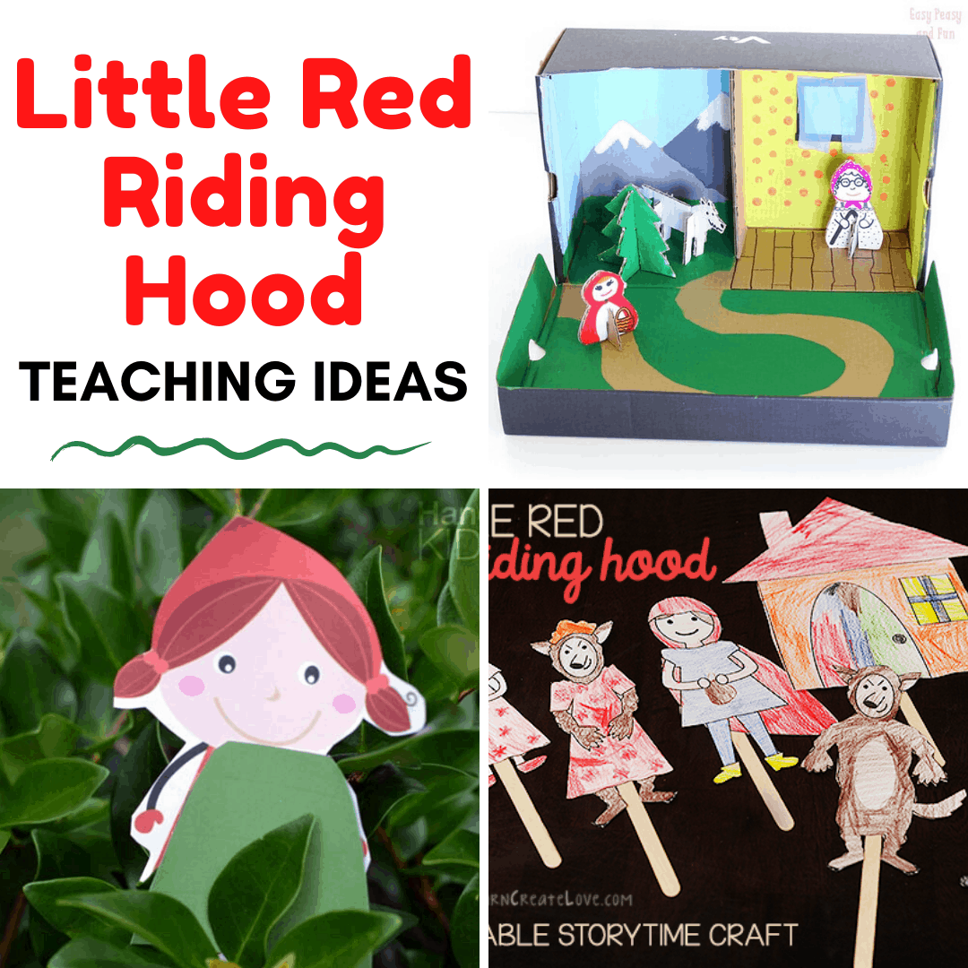

**Creating your own map!**

At home create a map of your house or your garden. Remember to use the different symbols we have learnt in school or create your own for different areas. You need to include a key for you map.

